Pattadakal - Karnataka

**Location:**

Pattadakal, also called Paṭṭadakallu or Raktapura, is a complex of 7th and 8th century CE [Hindu](https://en.wikipedia.org/wiki/Hindu) and [Jain](https://en.wikipedia.org/wiki/Jain) temples in northern [Karnataka](https://en.wikipedia.org/wiki/Karnataka) (India).

Located on the west bank of the [Mallaprabha River](https://en.wikipedia.org/wiki/Malaprabha_River) in [Bagalakote](https://en.wikipedia.org/wiki/Bagalakote) district.

**History:**

Pattadakal was considered a holy place, being where the Malaprabha river turned northwards towards the Himalayas and the Kailasha mountain.

As its name implies, it was used during the [Chalukya dynasty](https://en.wikipedia.org/wiki/Chalukya_dynasty) for coronation ceremonies, such as that of [Vinayaditya](https://en.wikipedia.org/wiki/Vinayaditya_of_Vatapi) in the 7th century.

**vlog:**

<https://youtu.be/i_fu5h2tamU>

**Top 11 Places To Visit In Pattadakal, Karnataka**

* **Museum Of The Plains And Sculpture Gallery:** Home To Rare Scriptures
* **Virupaksha Temple:** Devoted To Lord Shiva
* **Mallikarjuna Temple:** Eye-Catching Architecture
* **Kashi Vishwanath Temple:** Nagara Style Monument
* **Papanatha Temple:** Fusion Of Dravidian And Nagara Architecture
* **Sangameshwara Temple:** Tranquil Ambiance
* **Galaganatha Temple:** Enormous Sikhara
* **Jambulinga Temple:** Marvellous Sculptures
* **Kadasiddeshwar Temple:** Well-Craved Dwarapalakas
* **Pattadakal Jain Temple:** Fine Carvings
* **Badami:** Historical Site

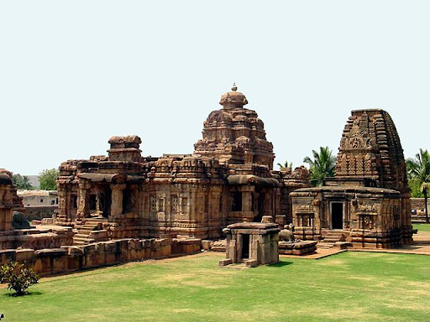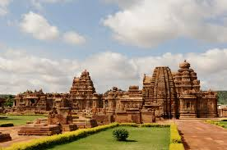

Vlog:

<https://youtu.be/hckJFn7wcv4>